# DSKB on Blacklight Set Up using Cloud9 IDE:

Setup account at <https://c9.io>

You will have to provide a credit card, but it is free until you upgrade .

1. **Click “Create New Workspace”**

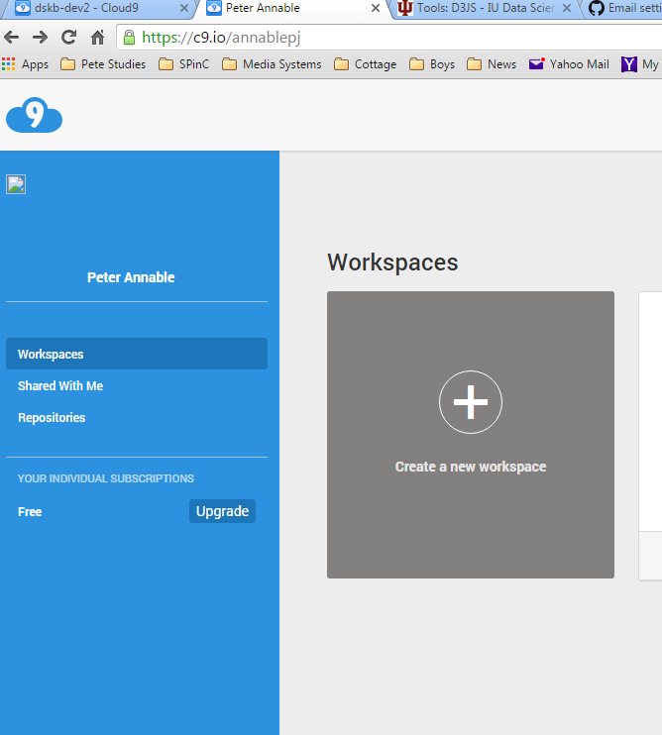

1. **Give your workspace a name like “dskb-dev”, a description, and enter** <https://github.com/annablepj/dskb> in the Clone from Git field.  
     
   Select “Ruby” template  
   Click “Create workspace”

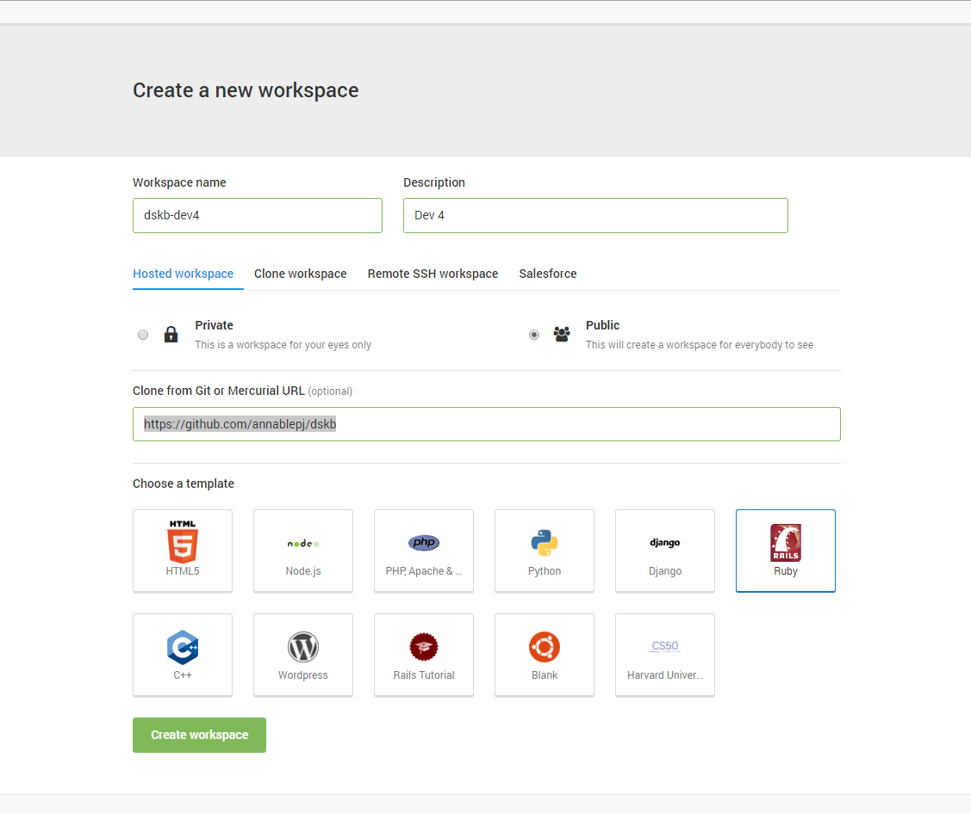

1. **You should get a workspace that looks like this:**

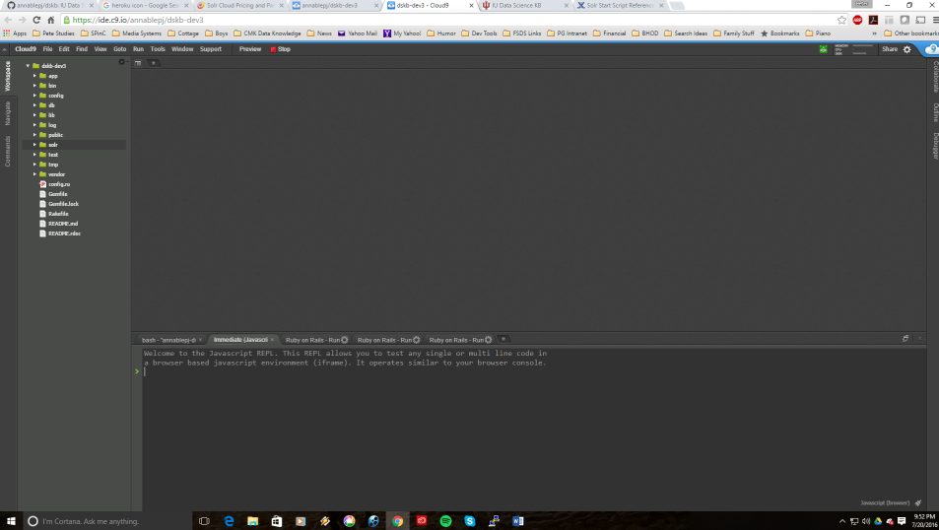

1. **Open a Terminal Window, run bundle to update your Gems:**

annablepj:~/workspace $ bundle install

1. **Perform database migrations:**

annablepj:~/workspace $ rake db:migrate

1. **Update Java to Version 8 (required for SOLR)**
2. sudo add-apt-repository ppa:webupd8team/java
3. sudo apt-get update
4. sudo apt-get install oracle-java8-installer

*(watch for prompts – hit OK to accept)*

**7. Set Java 8 as the default version**

sudo apt-get install oracle-java8-set-default

Confirm it by entering “java –version” you should see:

java version "1.8.0_91"

Java(TM) SE Runtime Environment (build 1.8.0_91-b14)

Java HotSpot(TM) 64-Bit Server VM (build 25.91-b14, mixed mode)

**8. Install SOLR within your Cloud9 IDE, using the following commands**

cd /home/Ubuntu

mkdir solr

cd solr

wget <http://apache.claz.org/lucene/solr/6.1.0/solr-6.1.0.tgz>

tar xvf solr-6.1.0.tgz

cd solr-6.1.0

**Now start SOLR and create the index:**

bin/solr start –p 8082 (Cloud9 doesn’t support using default solr port of 8983)

bin/solr create –c dskb-core

**To load the index with the initial data in .csv files, do this:**

cd /home/Ubuntu/workspace/solr

./build_index.sh

1. **Click “Run Project” at the top of your IDE to start the Rails Environment.**

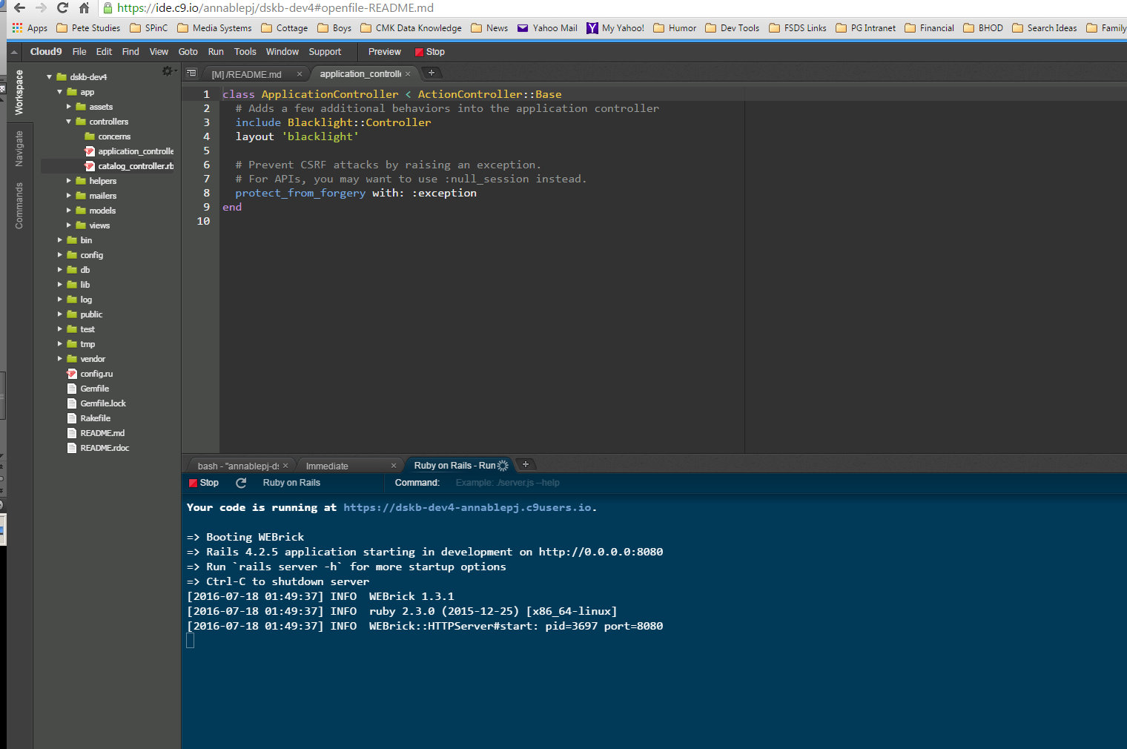

1. **Go to the URL provided in your browser to view the project:**

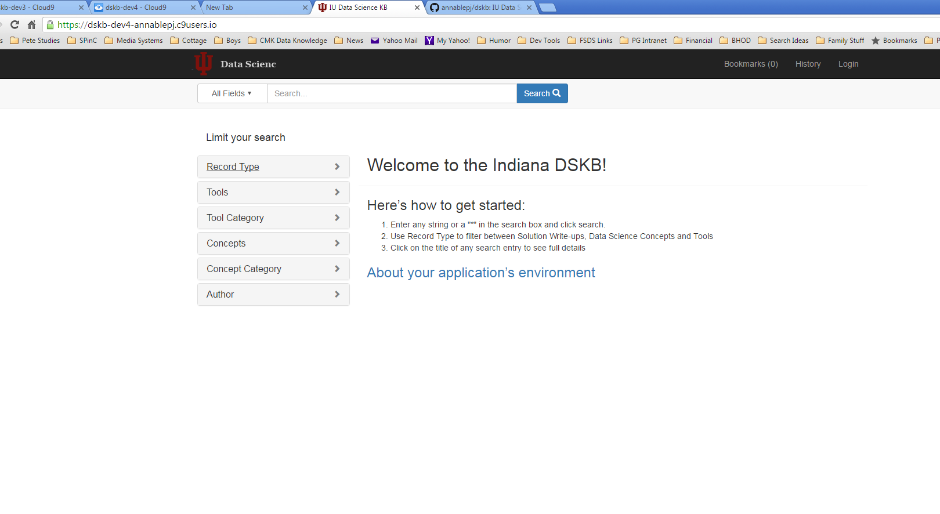

**Congratulations! You are running a local instance of the DSKB – now start developing!**